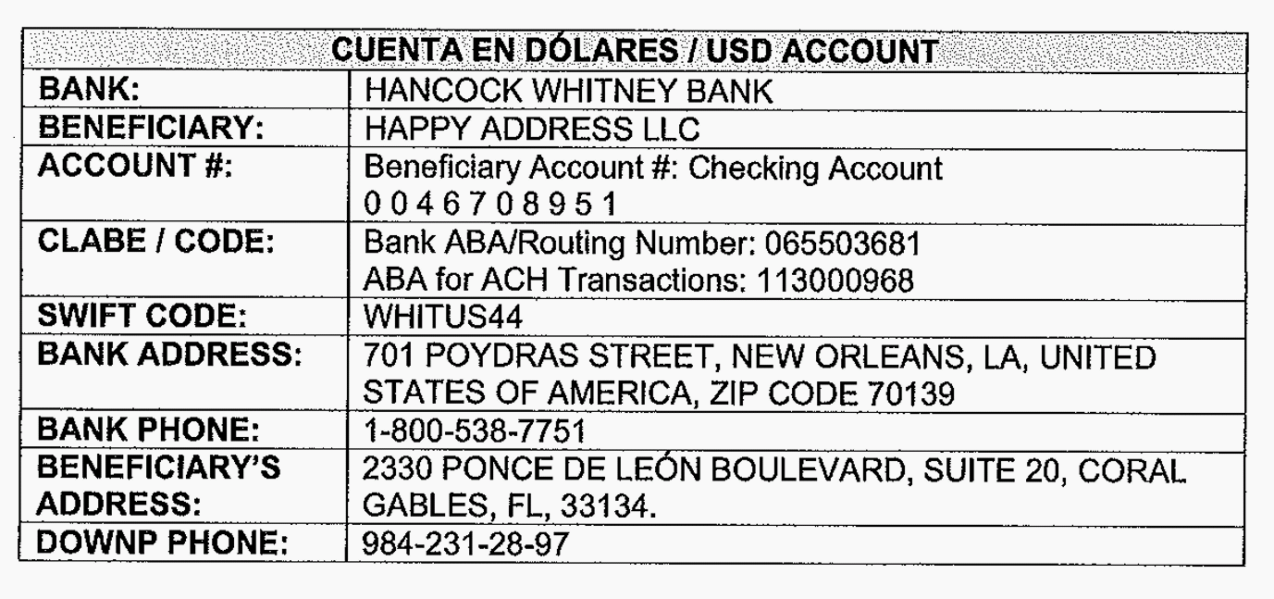
The 984-231-28-97 number needs a 52 International code in front.

